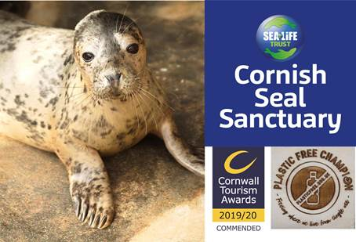

Cornish Seal Sanctuary, Gweek, near Helston, Cornwall, TR12 6UG

Tel: 01326 221361

**ANIMAL CARE PLACEMENT APPLICATION**

Thank you for your application for a volunteer work placement at the Cornish Seal Sanctuary.

We offer three types of volunteering placements with our animal care department:

* 2–6-week volunteering placement
* once a week regular volunteering,
* 3-month pup season internship (Oct-Dec or Jan-March)

Please make clear during the availability section which type you are applying for. Due to high demand, all placements require a £50 admin fee to secure placements dates, to be paid **after** dates have been discussed.

Complete the details below clearly and in **BLOCK CAPITALS**, and send by email to the work experience coordinator at: [G.Workexperience@sealifetrust.com](mailto:G.Workexperience@sealifetrust.com)

# PERSONAL DETAILS

|  |  |
| --- | --- |
| NAME | EMAIL ADDRESS |
| HOME ADDRESS | TELEPHONE NUMBERS  HOME:  MOBILE: |
| DATE OF BIRTH | COLLEGE/UNIVERSITY NAME |
| AGE | COLLEGE/UNIVERSITY COURSE NAME |
| EMPLOYER ADDRESS & TEL NO. | COLLEGE/UNIVERSITY ADDRESS & TEL NO. |
| OTHER QUALIFICATIONS | PLACEMENT DATES REQUESTED  (Please note it is helpful to provide multiple options if your first choice is unavailable) |

PLEASE USE THE SPACE BELOW TO INCLUDE ANY FURTHER INFORMATION SUCH AS RELEVANT WORK EXPERIENCE. IF YOU HAVE A C.V. THEN IT WOULD BE USEFUL IF IT WERE INCLUDED.

|  |
| --- |
|  |

#### MEDICAL FORM

Volunteers must provide us with the following information before their placement commences.

This form is confidential, and the details will not be disclosed without consent.

**In the event of an incident it may be necessary for us to contact your doctor.**

Doctor’s name:

Surgery Address:

Surgery contact number:

* Do you have an up to date Tetanus? YES NO

All volunteers MUST have an up to date Tetanus check before their placement commences.

* Do, or will you have an up do date Influenza Vaccination? YES NO

(within the last 12 months until the end of your placement dates)

1. Are you able to confidently swim 25M? YES NO

We advise all volunteers have an up to date Influenza Vaccination to work with rescued seals pups, although working with rescued pups during your placement can not be guaranteed

If the answer to any of the below questions is ‘Yes’, please use the space provided to give details.

1. Do you have any allergies? YES NO
2. Do you have any serious medical conditions? YES NO
3. Are you in any way restricted from physical work? YES NO
4. Are you currently receiving any medication? YES NO

**Name of a person we can contact in the event of an Emergency and their relation to you:**

Name & Relation:

Address:

Contact numbers:

I declare that to the best of my knowledge the above information is correct and give consent for this to be used in the event of an incident.

Name (in capitals) ………………………….. Signed..........................................................  
  
 Date...........................................

If under the age of 18 at time of application, a parent/guardian must also sign

Name (in capitals) ……………………………. Signed…………………..………………