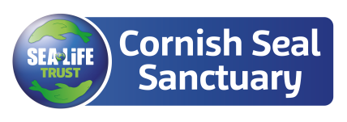

Job Title: Education Volunteer

Reports to: Education Team Leader

Scope of Job: Our Education Volunteers will be responsible for providing high quality educational interactions with our guests of all ages, ensuring the visitor experience is our primary focus. Education Volunteers will help drive a high-quality experience for our guests by inspiring and educating them in a fun, entertaining and engaging way.

Main Responsibilities:

Education Volunteers

- Assisting the Education & Events Team with on-site education and entertainments.
- Acting as a representative of the Cornish Seal Sanctuary on-site at designated seal pools and wildlife enclosures.
- Providing an on-site service that includes educating and assisting the general public.
- Talking to and interacting with guests, answering questions, supporting with enquiries and general customer service.

Key Performance Indicators

- Responsible for striving to deliver the highest of KPI scores and quality of work.
- Promoting quality customer care by ensuring a courteous, efficient, helpful service to the public, adhering to the Mystery Shop programs as a guide.

Conservation
As an operations department, we are committed to reducing our environmental impact and on educating our guests in the process. We are working towards reducing the plastic in our shop, working digitally to reduce our printing, educating guests on the importance of environmental conservation and offering food that is sustainably sourced.

